PROJECT DEVELOPMENT PHASE

SPRINT 2

TEST CASE

|  |  |
| --- | --- |
| DATE | 07 NOVEMBER 2022 |
| TEAM ID | PNT2022TMID17753 |
| PROJECT NAME | DEVELOPING A FLIGHT DELAY PREDICTION MODEL BY USING MACHINE LEARNING |
| MAXIMUM MARKS | 8 MARKS |

HOME PAGE:

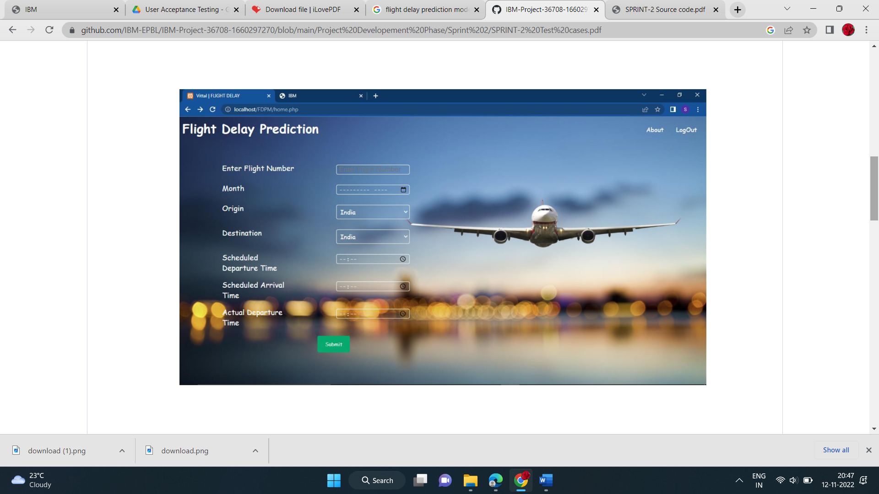

RESULT PAGE:

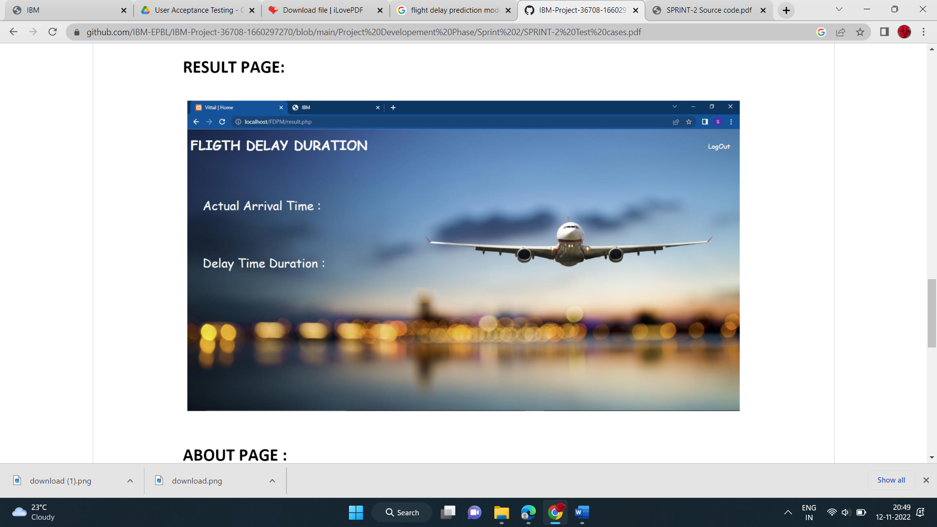

ABOUT PAGE:

